**1DAILY ONLINE ACTIVITIES SUMMARY**

|  |  |  |  |  |  |  |  |  |
| --- | --- | --- | --- | --- | --- | --- | --- | --- |
| **Date:** | **14-7-2020** | | | | | **Name:** | **poojashree** | |
| **Sem & Sec** | **8th sem A sec** | | | | | **USN:** | **4al16cs065** | |
| **Online Test Summary** | | | | | | | | |
| **Subject** | |  | | | | | | |
| **Max. Marks** | |  | | **Score** | | |  | |
| **Certification Course Summary** | | | | | | | | |
| **Course** | **Introduction to cyber security** | | | | | | | |
| **Certificate Provider** | | | **Great learning academy** | | **Duration** | | | **5.5hr** |
| **Coding Challenges** | | | | | | | | |
| **Problem Statement:**  1. **Display the powers of 2 using anonymous function** | | | | | | | | |
| **Status:completed** | | | | | | | | |
| **Uploaded the report in Github** | | | | | **yes** | | | |
| **If yes Repository name** | | | | | **Poojashree** | | | |
| **Uploaded the report in slack** | | | | | **yes** | | | |

**Online test**

**----------no marks -----------**

**Certification course**

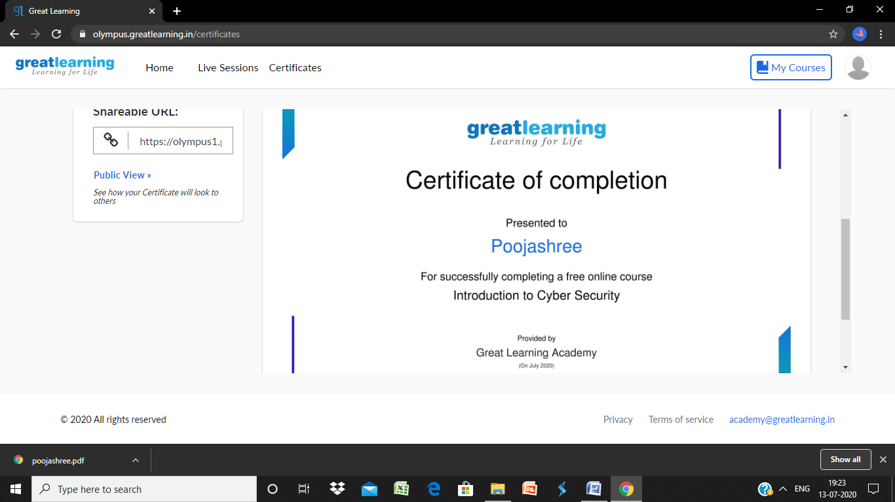

**Coding**

**Program 1**

terms = 10

result = list(map(lambda x: 2 ** x, range(terms)))

print("The total terms are:",terms)

for i in range(terms):

print("2 raised to power",i,"is",result[i])